Are there medications that can help with needle pain?
Yes. LMX-4 (Lidocaine 4%) cream can be used to numb the skin and surrounding tissue. Apply LMX-4 cream to the skin and leave it on for at least 30 minutes and no more than 1 hour before vaccines. The numbing effect lasts 1 hour after removal.
What needle procedures is it used for?
LMX-4 numbing cream can be used before vaccines in patients 3 years of age or older.
Where can I purchase numbing cream?
You can purchase the cream at an online or in person pharmacy without a prescription. As with any over the counter medicine, please read and follow package instructions closely.
What are possible reactions to this medication?
Redness, rash or irritation of the skin, unusual feeling in the area around the cream, temporary paleness of the skin.
How much do I use?
If your child is 3 years of age or older: put a square of 1 x 1 inch of cream in a thick layer on the skin 30 minutes before vaccination. Do not use more than 1/2 of a 5 gram tube per body part.
How do I put on the numbing cream?
- Do not wash the skin since the cream works best when it mixes with the skin’s natural oils.

- While wearing gloves, rub a small amount of LMX-4 cream into the site pictured (the deltoid muscle).
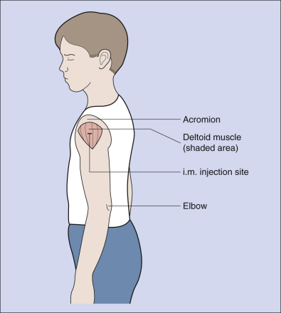
Apply cream here. (shaded area)
- Next apply a thicker layer of cream to the same site and leave it in place in a 1X1 inch square. Do not use more than 5 grams in 24 hours.

- Cover the cream with a clear plastic dressing such as tegaderm pictured below. You can also use plastic wrap from a grocery store.

- Remove gloves and wash hands

- A nurse will remove the cream in the office just prior to your child’s vaccination. You should wipe the cream off in an hour if you have not yet been seen in the office.

